Foundation for Virtual and Augmented Reality Systems
Prof. Samit Bhattacharya
Department of Computer Science and Engineering
Indian Institute of Technology, Guwahati
Week – 10
Lecture – 52
VR experience optimisation
Hello and welcome to the NPTEL MOOCs course on Foundations for Virtual and Augmented Reality Systems. We are going to continue our discussion on VR Navigation Experience Optimization, which we started earlier. So, earlier we talked about one way to address the problem of minimizing the possibility of CS or cyber sickness. in a system-controlled virtual tour. And how did we do that?
We made use of one approach where we tried to figure out an optimal path covering all vertices in a given graph representing the virtual world which can be traversed in minimum time. That was one approach. There is one more approach which we are going to talk about in this lecture. Now, that other approach is essentially to find out an optimal path covering the maximum number of points of interest or POIs given some time constraints. So, earlier we did not have a time constraint.
Our objective was to find a path covering all vertices. that can be traversed in minimum time. Now we are imposing one time constraint and our objective is to find out a path, given this time constraint, where the number of POIs covered will be maximum. So, in order to find that time constraint, time threshold, we need to define such a threshold, a time threshold. So, earlier we saw how to compute an optimal tour.
where the path covers all nodes in minimum time. The problem is that that minimum time may still be more than the time typically associated with the onset of cyber sickness. So, that minimum time, although it is minimum given all possible paths, may still be responsible for inducing cyber sickness. It may still be more than the time threshold above which CS occurs. So, we are talking about something called a time threshold.
So, essentially, our objective should be to restrict the movement time, or the experience time of the user, or the VR exposure time of the user, within this threshold. If we cross it, then there is a possibility of cyber sickness. Now, let us call this time threshold TTH. as shown here. So, essentially, what we are trying to do is find an optimal path that completes within the threshold time.
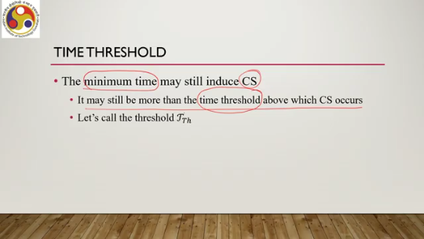
Now, when I say complete, essentially that means that the user should be able to cover the optimal path within this time threshold. And this time threshold can be the duration of the virtual tour, the maximum duration of the virtual tour. Now, of course, there is no easy way to find out the time threshold. Of course, there are some studies which recommend some thresholds, which depend on the content.
Sometimes it may also depend on the speed of movement and so on. And we can obtain the threshold value through some empirical study with a limited number of users. That is one possibility. We can also use some pre-existing study results to decide on a threshold. Now, when we are talking of a time threshold and when we are talking of covering a tour or completing a tour within the given time threshold, it is not mandatory and not always possible also to visit every single node or vertex which represents the points of interest. So, essentially, here what we are saying is that we want the user to complete a tour within a given time threshold and during that tour, we are fully aware of the fact that the user may not be able to cover all points of interest, unlike in the previous approach. Now, in order to take this into account to formulate our overall problem, we defined a term called the importance of every node, how important a node is.
Unless we know the importance, we do not know which nodes to cover within the given time threshold. In order to do that, we can define an importance function, a function that computes importance or assigns importance to every node, which is in the form $F:V→ R^{+}$. In other words, every vertex is mapped to every vertex or every point of interest, $v∈V$, maps to a positive real number which indicates the importance. So, we are capturing the importance in terms of a positive real number. The more the number is, the higher the importance.

Then, once we define the idea of importance for every node, what can we do? We can compute the total importance of a given path. Suppose we have a path P containing the nodes V1 to Vn. Now, each node has its importance. So, the total importance of the path can be defined as $F(p)$, which is $\sum_{i=1}^{n}{F(v_{i})}$, and n is the number of nodes in the path. It is a quite obvious formulation that to identify or determine total importance, we simply add up the individual importance of each node in a given path. So, then, in terms of that, we can have a problem statement: we want to maximize $F(p)$, that is, the total importance for paths that can be completed within the time threshold $T_{th}$. In other words, we want to basically identify a path which takes time less than or equal to the threshold time, but in which we are maximizing the total importance.
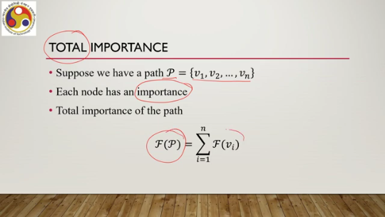
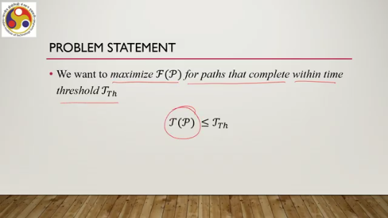
Now, there is another important aspect that needs to be considered, which is the waiting time. So, at a given point of interest, the user is expected to spend some time to inspect or to do something with that point of interest, as we have indicated in our earlier lectures during the experiments we have done. So, this waiting time is also a concern when we are trying to figure out a path maximizing the total importance. Now, this waiting time is essentially the time required by the user to inspect or interact with a particular object at a node that is the point of interest. So, like the importance function, we can also have a waiting time function. So, we can define this function, the waiting time function, as W where V is mapped to a real positive number. In other words, every node is mapped to a real positive number. which indicates the maximum time required to inspect or interact with the object that is there at V. So, this is the maximum time a user requires to spend at the point of interest.

So, now we have two quantities: one is importance, and the other one is waiting time. So, two quantities are associated with each node: one is importance, and the other one is the waiting time. Like total importance, we can also calculate total waiting time in a similar manner. Suppose we have a path P having all these vertices v1 to vn, n nodes, each node has an associated waiting time; then the total waiting time w
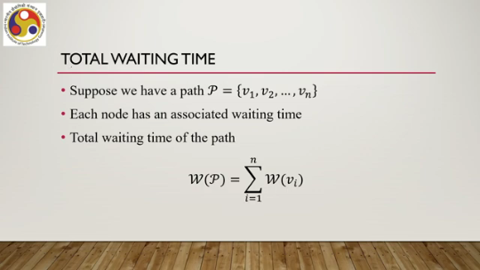
$W(P)$ equals the summation of individual waiting times for all the nodes i equal to 1 to n. So, again, it is quite obvious, like the total importance calculated earlier. Then we need to revise our earlier problem statement. What is that revision? We want to maximize the total importance for paths that complete within the time threshold $T_{th}$, taking into account the waiting time.
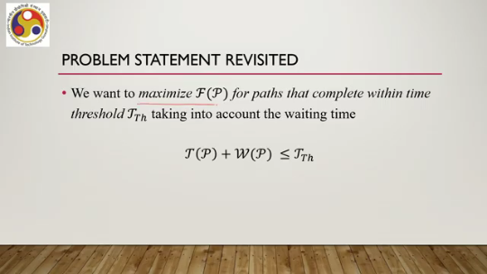
So, essentially what we want to state is $T\left(P\right)+W(P)$ must be less than or equal to $T_{th}$, where we are also maximizing FP. Now, how do we solve this? This is a well-known problem in operations research. It is called a generalization of a well-known problem, that is, the vehicle routing problem or VRP. This is called VRP with profit, or VRPP.
For more details on this problem, you can refer to the material cited at the end of this lecture. So, the idea here is that we do not need to visit all the nodes; instead, we want to maximize profit within the given time constraints. So, here the profit is in terms of the importance of the nodes. So, we want to maximize the importance within the given time constraint without
necessarily requiring us to visit all the nodes. Like in the previous approach where we talked about TRP solvers, so existing tools available to solve the traveling salesman problem, here also we can make use of existing VRPP solvers, so vehicle routing problem with profit solvers. to get the optimum path that maximizes profit within the given time constraint, that is, the threshold time. And maximizing profit essentially maximizes importance, the total importance.
So, in other words, we want to get a path that lets the user visit the maximum number of the most important POIs. This is a rephrasing of the overall problem that we are trying to solve. And if you look at this statement, you can see that this will serve our purpose: given a threshold, a time threshold beyond which cybersickness may occur, we want to restrict the user's exposure below that threshold time and within that time, we want to ensure that the user is able to visit the most important POIs, as many as possible.
So essentially, we are trying to figure out a path that will achieve these objectives. So let us quickly go through the algorithm. So the input is the graph. Remember that during our earlier discussion, we talked about converting the virtual environment to a graph, which is not necessarily a complete graph, but a fully connected graph. So, we have this original graph G having the vertex set V and edge set $ϵ$, along with the importance f and waiting time w specified for each of the nodes, and the output that we want is this optimal path P where F is maximized and the total traveling time plus wait time is less than the threshold. So, earlier we talked about only traveling time, but now we also have to take into account the wait time. So, traveling time plus wait time, which together represent the total exposure time, must be less than the time threshold. So, the first thing is, as before, what we need to do is compute the complete graph $G'$, where we will be replacing the edges that are not directly connected with the shortest path between those vertices.
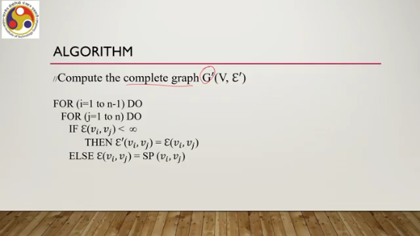
This is what we did before also. So, the same thing we will be doing here. Convert the graph to a complete graph. Then again, the second stage is also the same: replace the edge weights, which are originally the Euclidean distance between the two nodes in the modified graph, with the travel time t as we did before, where travel time we compute using the natural walking model.
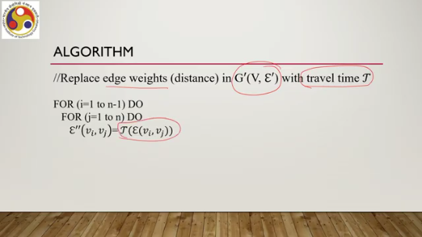
Then, once this is given, Also, we have separately specified the importance and the wait time. So, we then need to use the VRPP solver with input the final graph, that is $G''$, which contains vertices and edges where the edges are weighted with the duration of travel between the vertices which define the edges. So, essentially, we will be using a solver on this modified graph $G''$, and also we will be providing the input values for f, the waiting
the importance of each node, and w, that is the waiting time for each node, to get the optimal path P opt. So, here we will be using the solvers solve VRPP where the input is $G''$, F, and W, then we get the output as P opt. Now, like before, what we need to do is basically modify the output to reflect the original graph. So, what we need to do is there will be edges that were not originally connected in the
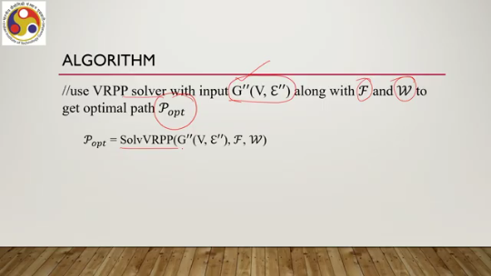
Virtual graph virtual world representation, but we introduced hypothetical edges in the form of shortest paths. So, we need to replace those edges to reflect the original nature of the graph. So, replace hypothetical edges joining $V_{i}, V_{j}$ with the shortest path $V_{i}, V_{j}$. Then we need to return the optimal path which is modified after replacing the edges with the shortest path.
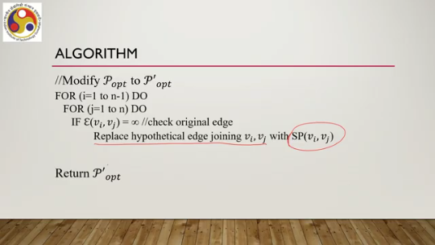
So, this is the algorithm: we are first creating the graph, then converting it to a complete graph, then converting it to a graph with edge weights equal to the travel duration, where travel is the duration computed using the natural walking model to give a realistic experience. Then this graph, along with the importance and wait time at each node, is provided as input to the VRPP solver, and then the output is further modified to replace the hypothetical edges with the shortest path to finally get the optimum path.
that can be covered with the maximum number of most important POIs within the given time threshold, taking into account waiting time at each node. So, let us summarize what we have learned so far. So, we are talking about experience optimization. So, there we talked about a couple of approaches to take care of the CS issues. cyber sickness issues. First, we talked about identifying an optimal path in a given graph representation of a virtual environment which can be covered in the minimum time now for a given large environment, this minimum time may not be addressing the cyber sickness concern because this time may still be large enough to induce cyber sickness. So, in order to address that, we are going for another optimal path formulation where we talked about node weights, where we talked about the node importance and waiting times. Then we talked about a time threshold, and then we are trying to find out an optimal path that can be covered by the user within the time threshold, taking into account the importance of each node and the waiting time at each node.
In other words, this optimal path will allow the user to cover the maximum number of the most important POIs within a given time threshold, taking into account the time required to spend at each point of interest to inspect or interact with the object present there. So, in the next part of the lecture, we will have a quick look at how this idea has been put into practice in the context of our case study. So, looking forward to meeting you again in the next part of this lecture, which will be the final part of this particular topic of experience optimization. So, I hope you could follow the discussion.
Thank you, goodbye, and happy learning.

